KUMARAGURU COLLEGE OF TECHNOLOGY

24ADT015-FINANCE, ECONOMICS AND MARKETING

NAME : Nishanth P
ROLL NO : 24BAD405

IND AS-07 – Statement of Cash Flows
Statement of Cash Flows:
IND AS-7 prescribes how companies must prepare and present the Statement of Cash Flows. Its purpose is to show how cash enters and leaves a business, helping assess liquidity, solvency, and overall financial health.

1. Objectives of IND AS-07
- To provide information about cash inflows and outflows during a period.
- To help users evaluate:
  - Ability to generate cash
  - Ability to repay debts and pay dividends o Reasons for difference between profit & cash o Impact of investments and financing decisions on cash
2. Classification of Cash Flows
According to IND AS-7, cash flows must be classified into three activities:

A. Operating Activities
Activities that form the core business operations of a company.

Examples:
- Cash received from customers
- Cash paid to suppliers
- Wages & salaries
- Operating expenses
- Income tax paid
- Cash received from royalties, commissions (if operating in nature)

IND AS-7 allows two methods:

1. Direct Method
Shows actual cash inflows and outflows:
Cash received from customers
- Cash paid to suppliers
- Cash operating expenses
= Cash from operations

2. Indirect Method
Starts from Net Profit and adjusts for non-cash and working-capital changes:
Net Profit
+ Depreciation (non-cash)
+ Loss on asset sale – Gain on asset sale
± Changes in inventory, receivables, payables
= Operating Cash Flow
Most companies use the indirect method.

B. Investing Activities
Cash flows relating to long-term assets and investments.
Includes:
- Purchase or sale of PPE (property, plant, equipment)
- Purchase/sale of investments
- Loans given/received
- Interest or dividends received (depending on policy)

C. Financing Activities
Cash flows relating to capital structure.
Includes:
- Borrowing and repayment of loans
- Issue of shares or debentures
- Dividend paid
- Lease liability payments (as per IND-AS 116)

3. Cash & Cash Equivalents
According to IND AS-7, these include:
- Cash on hand
- Demand deposits
- Short-term, highly liquid investments
(3-month maturity or less)

4. Key Adjustments Required Under IND AS-7
- Non-cash items (depreciation, amortization)
- Unrealized FX gains/losses
- Non-operating profit/loss (on sale of assets)
- Working capital changes (inventory, receivables, payables)
- Reclassification between activities based on the nature of business

IND AS-116 – Leases
IND AS-116 provides guidelines for accounting for leases. It introduces a unified model for lessees based on the concept of Right-of-Use (ROU) Asset and Lease Liability.
This standard replaces the earlier IND AS-17.

1. Scope
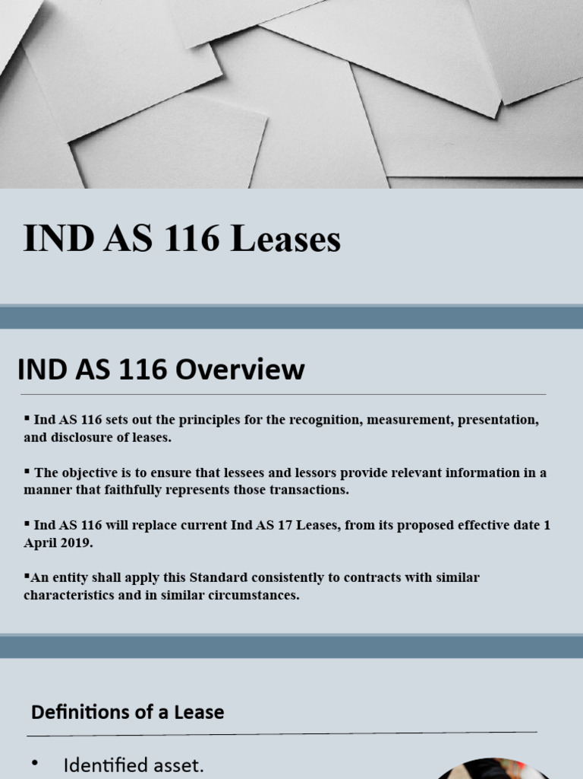
IND AS-116 applies to all lease contracts, except:
- Biological assets
- Exploration and evaluation resources
- Service concession arrangements
- Licenses of intellectual property
- Leases of intangible assets
2. Key Concepts

A. Lease
A contract that transfers the right to use a specific asset for a certain period in exchange for payment.
- Right-of-Use (ROU) Asset
An asset representing the lessee’s right to use an underlying leased asset.
- Lease Liability
The present value of future lease payments the lessee is obligated to make.

3. Lessee Accounting
Under IND AS-116, all leases are treated similarly, except for short-term and lowvalue leases.

Initial Recognition
The lessee must recognize:
- ROU Asset, measured at:
  - Lease liability amount
  - Lease payments made at or before commencement
  - Initial direct costs
  - Estimated restoration or dismantling costs
- Lease Liability, measured at:
Present value of future lease payments using the interest rate implicit in the lease or incremental borrowing rate.
4. Subsequent Measurement

A. ROU Asset
- Depreciated over the lease term or useful life, whichever is shorter
- Subject to impairment testing

B. Lease Liability
- Increased by interest
- Decreased by lease payments
- Remeasured if lease terms or rates change

5. Exemptions
A lessee may opt not to apply full IND AS-116 for:
- Short-term leases (12 months or less)
- Low-value assets (example: laptops, office equipment)
Expenses for these are recognized on a straight-line basis.
6. Lessor Accounting
Lessor accounting remains similar to previous standards:

A. Finance Lease
- Lessor derecognizes asset
- Recognizes lease receivable

B. Operating Lease
- Lessor retains asset
- Recognizes rental income on straight-line basis

7. Derecognition of Leases
A lease (or part of it) is derecognized when:
- The asset is returned
- The lease contract expires
- A modification substantially changes the original terms
8. Impact on IND AS-07 (Cash Flow Statement)
Lease-related cash flows are classified under different activities:
Operating Activities
- Interest portion of lease payments
Financing Activities
- Principal portion of lease liability payments

Investing Activities
- Not generally applicable (unless ROU asset is sold or sub-leased)
Differences Between IND AS-07 and IND AS-116

Feature IND AS-07 IND AS-116
Purpose Reporting cash flows Accounting for leases
Recognition of ROU assets and
Focus Classification of cash inflows/outflows
lease liabilities
Balance Sheet (ROU asset &
Output Statement of Cash Flows Liability)
Lease payments split into operating and Affects cash flow classification in
Link
financing cash flows IND AS-07

